

APP DEVELOPMENT GUIDE

Index
Introduction 3
Overview 3
Purpose 3
Main Files 3
Installation 3
Imports 3
Data Fetch 4
CSS 4
JSON File 5
URLs 5
Firebase URL 5
Web Page URL (Dynamic) 6
Song URL (GitHub Hosted MP3s) 6
Logo URL (GitHub Hosted PNG) 6
Key Functions 6
Search Index Management 6
Fetching Pages for Indexing 6
Search Execution 6
Managing Search Queries 7
Validation of Terms 7
Merging Index Data 7
Managing URLs 7
Admin Dashboard Functions 7
Chatbot Responses 7
Statistical Analysis 8
User Interface Management 8
Music Player Functionality 8
Interesting Design Patterns/Code Templates 8
Use of ipywidgets 8
Use of CSS for Interface Design 9
Music Player 10
Chatbot Page 10
Statistics Page 11
Admin Page 11
Results Page 12

Introduction

Overview
The system includes a user-friendly interface with search capabilities, providing URLs to Oracle pages, statistics dashboards, a chatbot assistant, and a music player to enhance user experience. An admin interface enables efficient management of indexed data and music playlists.

Purpose
This project is a search engine application designed to index, search, and evaluate web content. It allows users to perform searches with logical operators (AND/OR), view detailed results, and access analytics such as term frequencies and popular queries. The application integrates Firebase for data storage, ensuring dynamic updates.

Main Files

Installation
The "Installation" section outlines the commands needed to set up the required libraries and packages. This step is essential to organize the development environment correctly and ensure that all dependencies are installed for the application to work seamlessly.
For instance:
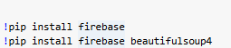
These commands install libraries for creating interacting with Firebase (firebase).
Note: The Password for Admin Page is: 123456

Imports
The Imports section specifies all the libraries and modules included in the project. Each import is necessary to access specific features that the application relies on to perform its tasks effectively.
For instance:
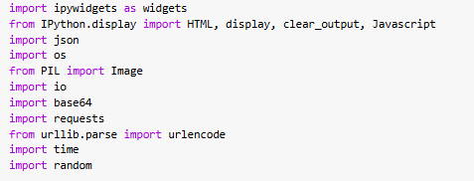
These imports bring in tools for creating widgets, displaying outputs, plotting data, and interacting with APIs and databases.

Data Fetch
This section focuses on fetching data from external resources. In this project, it primarily deals with obtaining data from Firebase. This functionality is critical as it supplies the application with the essential information required for analysis, processing, and display.
For instance:
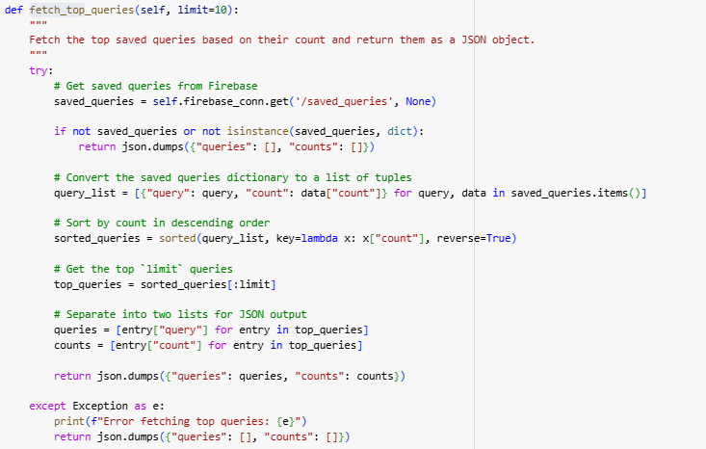

This method retrieves and processes the most frequently saved queries from Firebase.

CSS
This section includes styles that edits the application's user interface. These styles are essential for creating a uniform and aesthetically pleasing design, ensuring that the UI components are visually appealing and user-friendly.
For instance:
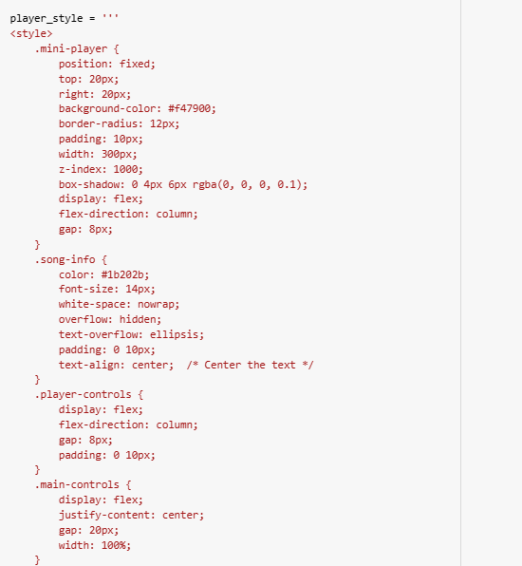

JSON File
The JSON File section focuses on working with and presenting JSON data files. These files are used to organize and maintain structured data, enabling efficient handling, interaction, and fitting of the data based on user actions or inputs.
For instance: we used to store the list of songs for the music player.
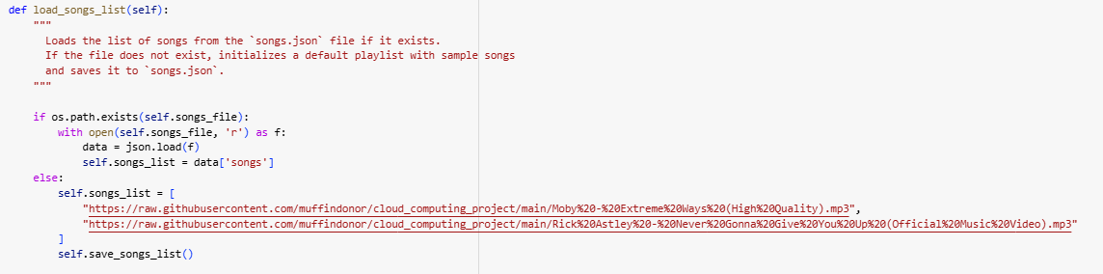

URLs

Firebase URL
This URL connects the app to the Firebase Realtime Database. It is used for storing, retrieving, and updating indexed data, search queries.
The URL initializes the Firebase connection to interact with the Database.

Web Page URL (Dynamic)
This URL is fetched based on the base_url parameter provided to the fetch_pages() function. It represents the web pages that app crawls and indexes for content. Links are extracted from the HTML <a> tags on the base page using BeautifulSoup.
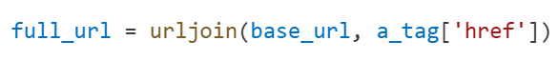

Song URL (GitHub Hosted MP3s)
This URL point to MP3 files hosted on GitHub and are used in the music player feature IN the application.

Logo URL (GitHub Hosted PNG)

This URL points to an image file (logo) hosted on GitHub. It is loaded and displayed in the app's user interface.

Key Functions

Search Index Management
def build_index(self) - (SearchEngine class)
The function creates and updates the word location index for efficient search.
It clears the current index and rebuilds it from fetched pages. It processes words, validates terms, and updates the index in Firebase.

Fetching Pages for Indexing
def fetch_pages(self, base_url, num_pages=5) - SearchEngine class
This function Crawl web pages to extract content for indexing.
Without this, the system wouldn't have any data to build the search index.
It fetches and processes up to `num_pages` from the given `base_url`. Extracts visible text content for indexing.

Search Execution
def search_query(self, query, search_type='AND') - SearchLogic class
This function is the core of the search engine, returning meaningful results based on user's queries.
It processes the query, applies AND/OR logic, and ranks results by relevance.

Managing Search Queries
def save_query(self, query) - SearchLogic class
This function saves, update, and analyze user search queries.
It saves user queries to Firebase, incrementing their count if they already exist.
def fetch_top_queries(self, limit=10) - SearchLogic class
This function Retrieves the most frequently searched queries.

Validation of Terms
def is_valid_term(self, term) - SearchEngine class
This function ensures that only valid terms are included in the search index.
It validates terms based on rules:
1. Term must be longer than 2 characters.
2. Term must not contain numbers or special characters.
3. Term must only contain English letters.

Merging Index Data
def merge_index_data(self, existing_data, new_data) - SearchEngine class
This function combines existing data from Firebase with new data from fetched pages.
It merges existing and new index data, ensuring no duplicate document IDs.

Managing URLs
def update_index(self, term, added_urls, removed_urls, current_docids)
This function adds or removes URLs dynamically in the search index.
It updates the index with new or removed URLs.

Admin Dashboard Functions
Provide admin with tools to manage the system.
def delete_index(self, term)
This function deletes an entire index term and its associated data from Firebase.
def refresh_index(self)
This function synchronizes local and Firebase index data.

Chatbot Responses
Responds to user queries through conversation and provides helpful insights.
def get_most_frequent_term(self, groups)
This function returns the term with the highest frequency in the indexed data.
def get_term_pages(self, term)
This function lists up to three pages containing the given term.
def suggest_search_term(self, term)
This function suggests related terms based on co-occurrence in documents.
get_term_document_count(self, term)
This function count documents containing a specific term.
get_top_terms(self, groups)
This function list top 5 most frequent terms

Statistical Analysis
Provides insights about the most frequent terms, URLs, and queries.
def fetch_top_indexes(self)
This function retrieves the terms with the highest total frequency.
def fetch_top_index_URL(self)
This function retrieves the terms with the highest number of associated URLs.
def fetch_top_queries(self, limit=10)
This function Retrieves the most frequently searched queries.

User Interface Management
Facilitates interaction between users and the system.
def show_search_screen(self)
This function displays the main search interface.
def show_results_screen(self, query, results)
This function displays search results based on user queries.
def show_admin_page(self)
This function displays the admin dashboard for managing the system.

Music Player Functionality
Enhances user experience with a built-in music player.
def load_songs(self)
This function loads a playlist of songs from a JSON file.
def create_mini_player(self)
This function generates a widget for the music player.

Interesting Design Patterns/Code Templates

Use of ipywidgets
Use of ipywidgets: The code extensively uses ipywidgets to create interactive elements in the notebook interface.
For instance: The code makes wide use of ipywidgets to build interactive components for the notebook interface. These widgets allow dynamic user interactions, making the application more engaging and user-friendly. For instance:
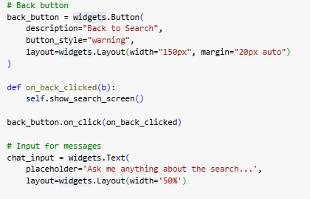
This code creates a Back button styled with a warning theme that navigates to the search screen when clicked and a text input field for user queries with a placeholder and custom width. Both widgets enhance interactivity in the user interface.

Use of CSS for Interface Design
It is used to enhance the appearance of the web application, ensuring the interface is visually appealing and easy to navigate.
Explanation:
- CSS is used to design the structure and appearance of web elements.
- It helps control features like colors, fonts, spacing, and alignment of components in a consistent way.
- Common approaches include creating reusable style definitions, using responsive techniques to adapt to different screen sizes, and tools like colored backgrounds or styled components for dynamic designs.
For instance:


Music Player
Enhances user experience with a simple music player that allows playback of a pre-defined playlist.
It Loads songs from a JSON file and displays them in a mini-player format.
Allows users to shuffle and play songs interactively.
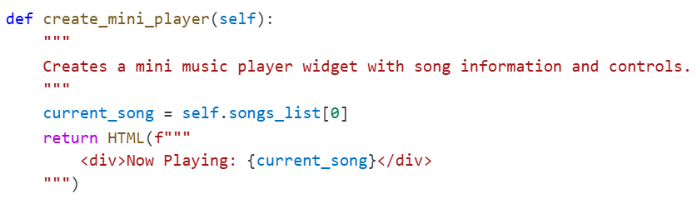

Chatbot Page
The chatbot provides conversational assistance for users, helping them understand search trends, related terms, and system functionality. It implements pre-defined patterns to respond to user queries. Handles tasks like showing frequent terms, suggesting related terms, and explaining system capabilities.
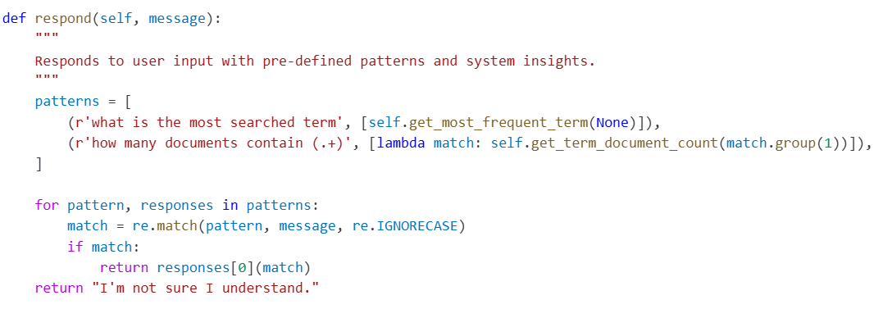

Statistics Page

The statistics page visualizes the most frequent terms, URLs, and user queries in a dashboard format.
It fetches data and, displays charts showing term frequency, URL usage, and query trends.
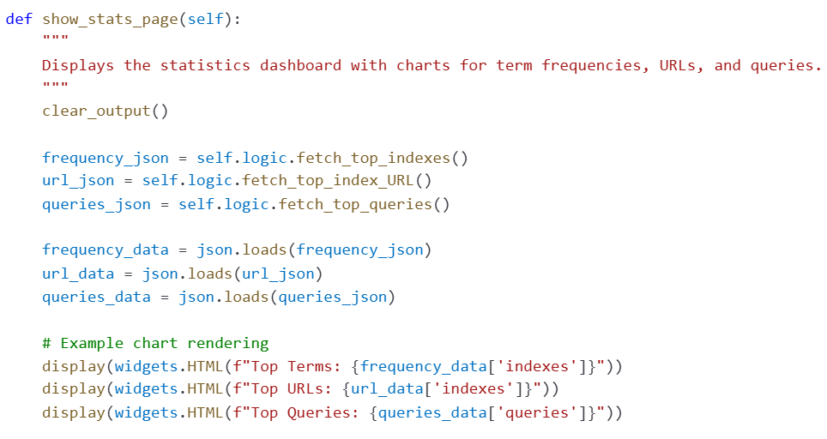

Admin Page
The admin page allows administrators to manage the index and music playlist, including adding, updating, or deleting terms and their associated URLs.
It provides dropdowns to select indexes and associated DocIDs. Includes input fields for adding new URLs. Allows deletion of specific DocIDs or entire indexes.

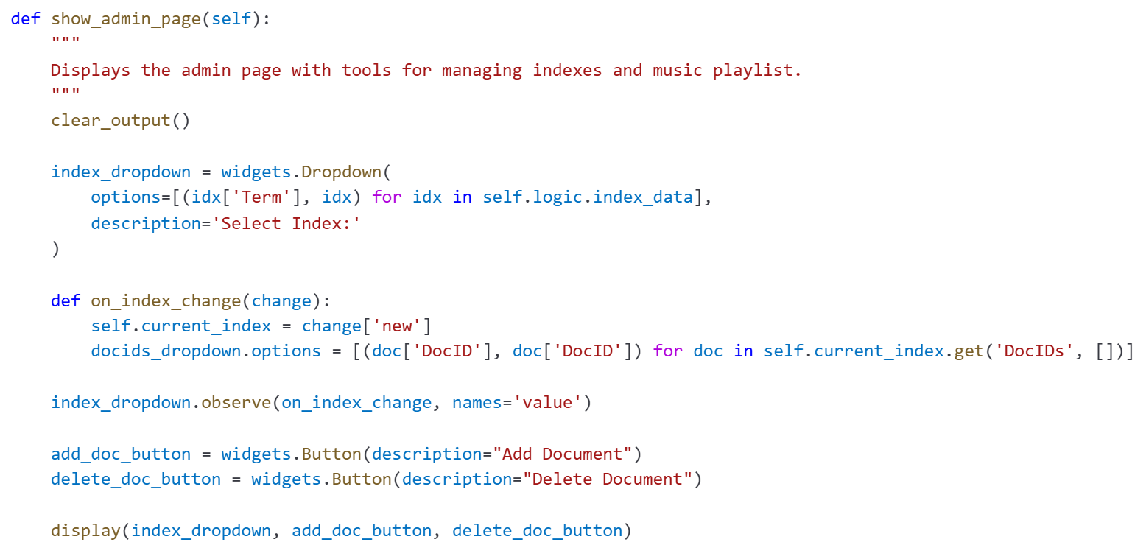

Results Page
The results page displays the search query results, including relevant links and their metadata.
It uses search_query results to display matching documents. Shows the number of results, their frequency, and titles. Provides a back button to return to the search screen.

